# [Title: OPERATION DEAD DEPLOY]

## Scenario

A junior intern at Mad Hat Labs created a test environment for an experiment that wouldn't be presented to leadership. Intern wasn't familiar with the company's governance standards and cut several corners. The intern deployed their environment and left the office for the weekend. I came in on Monday morning and found the environment the intern created. I need to access the damage, identify what governance failed, and document the evidence

## Environment
live multi-user Azure training tenant, Reader access.

## Investigation

- I logged in and looked at the resource groups to see if anything stood out. Resource group (testdeploy123) stood out compared to the other resource groups naming conventions.
- Inside resource group testdeploy123 only one resource created was a storage account
- Inside the resource, the owner of the resource created tags.

- Next, I needed to figure out the deployment that created the resource.
- I needed to figure out how the resource group and resource were created when there is a policy in place for resource group naming convention. After further investigation I found that the policy in question effect type was set to audit. This allows the resource group to be created even if the naming convention wasn’t followed. Instead of not allowing the user to create the resource after violating the policy, it flagged the resource group as non-compliant.
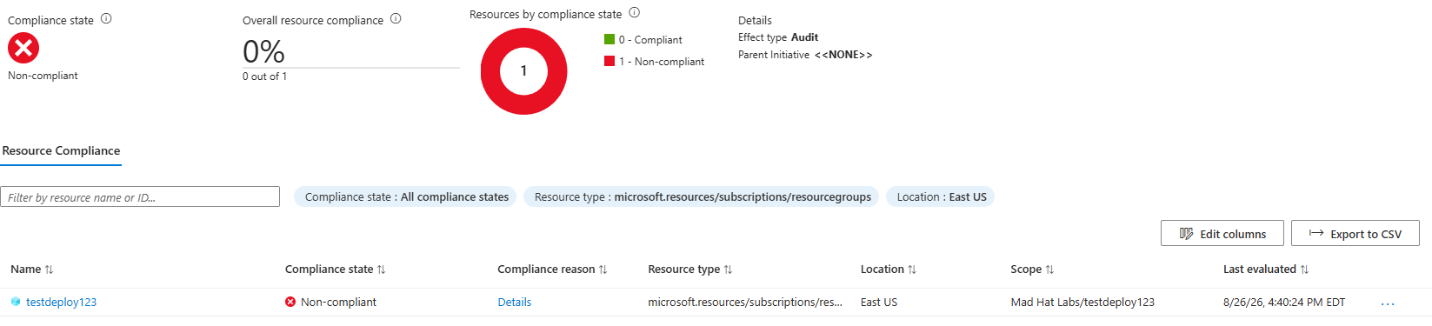
## What broke / what surprised me

I encounter issues at several points in these investigations. First issue I encountered was the resource group naming convention. When I did a quick scan of the available resource group, two stood out to me as a potential suspect to be further investigated. One of the resources in question didn’t have any resources created. The other resource group in question did. I still had doubts, so I looked at Microsoft docs for Azure resource group naming best practices and quickly noticed that one in question was the correct resource group that needed further investigation.
The second issue I encounter is the policy. I saw that there were policies created and one policy for naming convention. I couldn’t figure out how the resource group was created instead of being denied by the naming convention policy. I saw that the resource group was flagged but was still allowed to be created. I noticed that the naming convention policy effect type was set to audit. I looked through the Azure documents and discovered that audit doesn’t stop the resource group or resource from being created but instead flagged it as non-conformant. This is the reason how the user was able to create the resource group.

## Findings and recommendations
- Update naming convention policy effect type from “audit” to “deny”
- This would be a learning experience for the intern who created the resource group. Educate the intern on what he/she did wrong.
- Speak with the administrator who gave the intern temporary contributor access.
## What I learned
- In this investigation I learn about resource hierarchy (management group, subscription, resource group, and resources) and naming discipling (/subscriptions/{subscription-id}/resourceGroups/{rg-name}/providers/{provider}/{resource-type}/{resource-name})
- I learn about the importance of tags. Tags can provide valuable information about resources in question.
- I learn about the importance of deployment records. The deployment record can provide valuable information like who created the resource. You can correlate the deployment timestamp with security alerts.

